Diadoumenos
Name
Institution Affiliation
Date

Diadoumenos
The statue of Diadoumenos is an imitation of the inventive bronze tying a fillet on the head. Creation of the statue’s original copy was done in c.a 430 B.C by Polykleitos. The Greek sculptor who is creator of the statue worked throughout the mid-fifth century B.C. Other than Polykleitos’s love for art in general; he become the most known ancient artist in the entire world during the ancient times. He became famous because of the art that influenced people to believe that indeed great talents are out there. He got appreciation from known and respected people including famous business persons and the presidents of the nations (Beth, Harris). He got known as the most talented person during the ancient times. As one of top notch people worth to be remembered I will consider Polykleitos. It hurts seeing great people getting ignored despite them being famous during the ancient times.
The careful design on his figures contributed to him famous, that they had a superb attention toward the stance and the bodily portions. Definition on how the Diadoumenos statue was designed by Polykleitos, is evident that pelvis and thorax in the statue are tilting in the opposite direction indicating an organic vigor due to the portrayed cadence dissimilarities in the upper side of the body. The latent locomotion is evident by the feet poised between standing and walking. The above descriptions of the diadoumenos statues, defines statue in a way that the viewer and the readers understand. They are also able to get real image of the picture in Mind not necessarily having seen the picture using naked eyes.
The term Diadoumenos is used to refer to a youthful Man tying a fillet to his head or rather a man binding his hair. Diadoumenos statue is found in the New York City which is one of the most known cities in United States of America. It was formed in ancient times originally but in the in the Met currently. A youth using his fillet to adom his head is the depiction of the statue. The use of, a fillet to adom the head, traditionally was common among people after a win in an athletic tournament. The image symbolizes a Youth who is an athlete naturally and the diadem significance is the game winner
Diadoumenos work by Polykleitos, made him a famous artist that every person wanted being associated with. Polykleitos’s work was done using bronze, and no clear reason as to why he preferred using bronze. I assume maybe because bronze was the only Material available for Artwork. Despite the work Polykleitos being superb, it did not survive for long, approve that people should be discouraged to use bronze if they want their artwork to remain permanently. During the ancient times, artwork Made of bronze were melted and get converted to weapons. The other part of the statue is the marble part presented for the purpose of displaying in the Museum in Greece called National Museum of Athens.
In the ancient times, statues were duplication process were Made up of bronze. This Method was called pointing Method which was tiresome and was achieved in various stages. Artists using the Method use three aimed compass and a chassis which is a gadget that helped to complete the process. It involved rearrangement of points in the Model to copy. The Most bothering thing is that, a full scale model is required instead of the minuscule variety.
Tension, Blending and slackening of the work is all highlighted and also he ensured appropriate design creating attention on how the created body stood together with the other body proportion. Polykleitos is said to have created the most extensively used and famous contraposto stand; the contraposto Mie a posture having one meandering leg in a posture that is tranquil causing the appearance of the hip on one side. The posture is sometimes called chiastic drawn from letter X in Greek. The method gives perfect distribution weight making it a good method giving spine an S curve that gives a body balance both in structural Manner and the Aesthetical. Polykleitos created a posture leaving other artist to wonder if indeed they are artist too. Sincerely, many people keep using the naturalistic and appealing artwork almost exultantly throughout the ancient culture, classical era and even to date.
The diadoumenos statues generally has the unquestionable pleasant consequences. Statue represents a victorious bold sportsman who is a sensitive and soft. The eyelids together with eyes are whittled advantaging bystander creating a sense of deep connection. Statues lacks a structure of jawline and the head is rounded giving suggestions that this statue has a young age. This makes the statue friendly and amicable too. Furthermore, when we describing the statue’s beautifulness, we can have an opinion that his lips are small in size and are soft, the Man has a dimple in the chin and the hairs have chiseled ringlets.
The historians and aficionados of art learned depending on the Roman copies an example being the Diadoumenos statue version to construct and analyze work timeframe. Considering the research from scholars who researched More on artwork, bronze form of Greek drudgery is very limited making it worse, most of the Arts found to be partially intact and fragmented are the copies of Roman marble With no concern on that; humans ignore things which helped them once or their fore fathers. The Diadoumenos’s original version was stored at Metropolitan. Regretfully, if one goes to Met right now, he or she will find the forelimbs and hind limbs down to the knees. Tree trunks being the only original pieces at the Statue with no other parts. This indicates how as beings, we intend to be careless sometimes when it comes to keeping the things that ought to be kept for remembrance and for the coming next generations.
Comparing Bronze to the statue, neither is the marble that strong nor ductile and this makes it necessitate the structural pieces that are explicit to assist to hold up the extending extremes and limbs. Among artists in Rome, a copy of the statue was created by one of the Artist which Diadoumenos used key supports pieces in five places that are not similar. One piece grasps each Arms of the athlete while the other piece situated in the calves while fourth piece to holds up the fillet. Only one of the pieces to support is utterly kept and other pieces ignored or may be its remains were no sufficient to keep for certain reasons. Anthropologists and history researchers concluded that the headband was marble made entirely. This was helpful since bronze version was designed to help keeping the statue’s copy till to date.
Learning several statues is sometimes much important. Learning about the artists of the same is more important too. This is because, when they departure we should have learnt from them. To add on all this, the entire world have to develop a culture that celebrates various talents. This gives a person talented with the art the courage and feeling of being appreciated of that art they involve themselves in.
As I conclude, I would like to say that indeed the statue Diadoumenos’s posture resembles closely to Artwork by Polykleoitos called Doryphorous. The statue represents a young Man demonstrating balance and harmony by keeping polykleitos’s disreputable contrapposto together with hypothetical proportions. Indeed Diadoumenos and Doryphoros are the gifts of art presented to the world by Polykleitos. Despite him being gone, his Artwork remains to be recognized by the current generations and the generations to come. Polykleitos indeed was a talented genius.

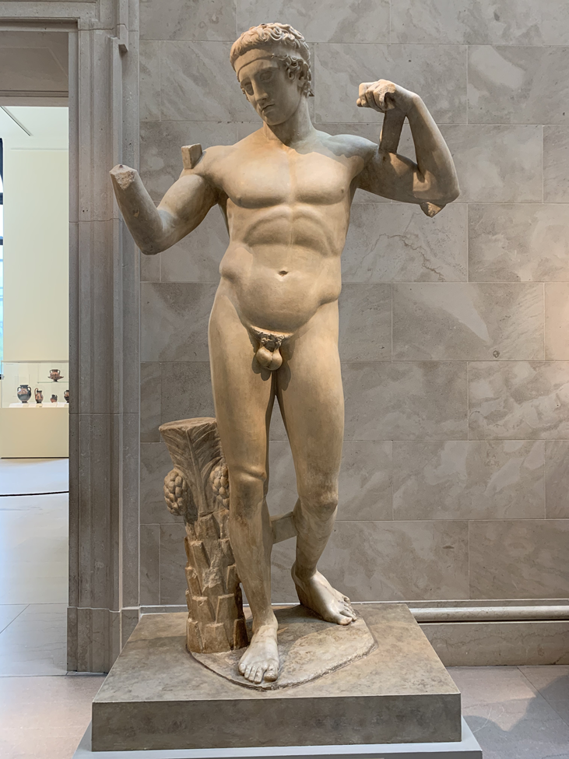



Bibliography
Brundige, Ellen N. "The Library of Alexandria." Ellen N. Brundige (2006).
Domain, Public. "Terracotta statuette of the Diadoumenos (youth tying a fillet around his head), 1st century BC." Dimensions 11, no. 7/16in: 29cm.
Domain, Public. "Marble statue of Pan, 1st century AD."
Domain, Public. "Fragments of a marble statue of the Diadoumenos (youth tying a fillet around his head), ca. AD 69–96."
Richter, Gisela MA. "Another copy of the Diadoumenos by Polykleitos." American Journal of Archaeology (1935): 46-52.

Richter, Gisela MA. "Another copy of the Diadoumenos by Polykleitos." American Journal of Archaeology (1935): 46-52.
Domain, Public. "Terracotta statuette of the Diadoumenos (youth tying a fillet around his head), 1st century BC." Dimensions 11, no. 7/16in: 29cm.
Domain, Public. "Fragments of a marble statue of the Diadoumenos (youth tying a fillet around his head), ca. AD 69–96."
Brundige, Ellen N. "The Library of Alexandria." Ellen N. Brundige (2006).
Domain, Public. "Marble statue of Pan, 1st century AD."

